BIOMECHATRONIC HAND

An “ideal” artificial hand should match the requirements of prosthetics and humanoid robotics.

It can be wearable by the user which means that it can be perceived as part of the natural body and should replicate sensory-motor capabilities of the natural hand. However ,such an ideal bionic prosthesis is still far from reality.

This paper describes the design and fabrication of a novel artificial hand based on a “biomechatronic” and cybernetic approach. The approach is aimed at providing “natural” sensory-motor co-ordination, biomimetic mechanisms, force and position sensors, actuators and control, and by interfacing the hand with the peripheral nervous system.

CONTENTS

- INTRODUCTION
- DESIGN OF THE BIOMECHATRONIC HAND
BIOMECHATRONIC DESIGN
ARCHITECTURE OF THE BIOMECHATRONIC HAND
ACTUATION SYSTEM
- DESIGN OF HAND PROTOTYPE
ACTUATOR SYSTEM ARCHITECTURE
KINEMATIC ARCHITECTURE
THUMB DESIGN
- HAND FABRICATIONS
- POSITION AND FORCE SENSORS
SENSORS
USE OF SENSORS IN ROBOTICS
POSITION SENSORS
HALL EFFECT SENSORS
SENSORS CHARACTERISATION
- FINGERED TRIP FORCE ANALYSIS
- FUTURE IMPROVEMENTS
- CONCLUSIONS
- REFERENCES

Chapter 1

INTRODUCTION

The objective of the work describe in this paper is to develop an artificial hand aimed at replicating the appearance and performance of the natural hand the ultimate goal of this research is to obtain a complete functional substitution of the natural hand. This means that the artificial hand should be felt by the user as the part of his/her own body and it should provide the user with the same functions of natural hand: tactile exploration, grasping and manipulation(“cybernetic” prosthesis). Commercially available prosthetic devices, as well as multifunctional hand designs have good reliability and robustness, but their grasping capabilities should be improved. The first significant example of an artificial hand designed according to a robotic approach is the Belgrade hand and the Utah hand which have achieved excellent results.These hands have achieved good performance in mimicking human capabilities, but there are complex devices requiring large controllers and their mass and size are not compatible with the strict requirements of prosthetic hands.

In fact the artificial hands for prosthetic application pose challenging specifications and problems, as is usually the case for devices to be used for devices to be used for functional replacement in clinical practice. These problems have forced the development of simple, robust, and reliable commercial prosthetic hand, s the Otto Brock Sensor hand prostheses which is widely implanted and appreciated by users. The Otto Brock Sensor hand has only one degree of freedom (DOF), it can move the fingers at proportional speed from 15-30 mm/s and can generate a grip force up to 100N.

According to analysis of the state of art, the main problems to be solved in order to improve the performance of prosthetic hands are

- lack of sensory information gives to the amputee;
- lack of “natural” command interface;
- limited grasping capabilities;
- Unnatural movements of fingers during grasping.

In order to solve these problems, we are developing a biomechatronic hand, designed according to mechatronic concepts and intended to replicate as much as possible the architecture and the functional principles of the natural hand.

The first and the second problem can be solved by developing a “natural” interface between the peripheral nervous system (PNS) and the artificial device(i.e., a” natural” neural interface (NI) to record and stimulate the PNS in a selective way. The neural interface is the enabling technology for providing the sensory connection between the artificial hand and the amputee. Sensory feedback can be restored by stimulating in an appropriate way user’s afferent nerves after characterization of afferent PNS signals in response to mechanical and proprioceptive stimuli.

Design of a
neural interface
Design of ENG Signal Processing Techniques
Interfacing the natural and the artificial world.
Design of a biomechatronic hand
Design of a Cybernetic Hand.

The control scheme for wearable artificial hands

In general, cosmetic requirements force to incorporate the entire device in a glove and to keep size and mass of the entire device comparable to that of the human hand. It turns out that the combination of robust design goals, cosmetics, and limitation of available components, can be matched only with the drastic reduction of DOF’s, as compared to those of natural hand. In fact, in prosthetic hands active bending of joints is restricted to only to two or three joints, while the other joints are fixed. Due to the lack of DOF’s prostheses are characterized by low grasping functionality and, thus they do not allow adequate encirclement of objects in comparison to the human hand; low flexibility and low adaptability of artificial fingers leads to instability of the grasp in presence of an external perturbation, as illustrated in. in conclusion commercial prostheses have been designed to be simple, robust and low cost, as the expense of their grasping ability.

This paper presents a novel multi-DOF hand several active joints, which is designed to obtain better grasping performance and natural fingers movements. The hand is designed according to a biomechatronic approach: miniature actuators and Hall- effect sensors are embedded in the hand structure in order to enable the control of available DOF’s. This paper describes a prototype of the artificial hand which has been designed, fabricated, and tested in vitro, in order to assess the feasibility of the proposed approach.

Chapter- 2
DESIGN OF THE BIOMECHATRONIC HAND

2.1 BIOMECHATRONIC DESIGN

The main requirements to be considered since the very beginning of prosthetic hand design are the following: cosmetics, controllability, noiselessness, lightness, and low energy consumption. These requirements can be fulfilled by an integrated design approach aimed at embedding different functions within a housing closely replicating the size, shape and appearance of the human hand. This approach can be synthesized with the term: “biomechatronic” design.

2.2 ARCHITECTURE OF THE BIOMECHATRONIC HAND

The design goal of the biomechatronic hand is to improve to some extent one of the most important limitations of current prosthetic hands (no dexterity and no adaptability), while preserving the main advantages of such hands, that is lightness and simplicity. This object has been pursued by using small actuators (two of each finger) instead of one single large actuator (as in most current prosthetic hands). And by designing a kinematics architecture able to provide better adaptation to object shape during grasping. It turns out that the use of “micro motors” allows to augment functionality in grasping objects by means of “human like” compliant movements of fingers. This result addresses the very basic requirements of “cosmetic” appearance of the hand in static and dynamic conditions.

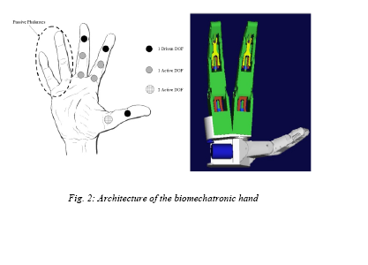

The biomechatronic hand has three fingers to provide a tripod grasp: two identical fingers (index and middle fingers) and the thumb.
In fact, as explained in, at least three fingers (non rolling and non sliding contact) are necessary to completely restrain an object.
These hands perform two grasping tasks:
1) Cylindrical grasp
2) Tripod grasp

The finger actuation system is based on two micro actuators which drive the Meta carpophalengal (MP) and the proximal interphalengal ( PIP) joint. The thumb actuation system is based on micro actuators and has two active DOF’s at the MP and the interphalengeal (IP) joint, respectively.
The grasping task performed by the hand comprises two subsequent phases.

1) Reaching and shape-adapting phase.
2) Grasping phase with thumb opposition.

In phase one, the first actuator system allows the finger to adapt to the morphological characteristics of the grasped object. In phase two, the second actuator system provides thumb opposition for grasping.

2.3 ACTUATION SYSTEM
The adoption of bulk and heavy actuators in the design of commercial upper limb prostheses, leads to an extreme reduction of DOF’s. The goal is to achieve stable grasp by means of high grip forces. This design philosophy can be represented as a loop.

Traditional actuators
One/two DOF’s
Large Forces
Low grasp robustness
Little contact areas
Low adaptability
Standard approach to grasp based on traditional actuators

The above schematization shows how this approach leads to design hands with a maximum of two DOF’s and able to obtain stable grasps using high pinch force (about 100N). To summarize, mechanical grippers such as state of art prosthetic hands, can generate large grasping forces and are simple to implement and control, but they are not adaptable and may cause problems of low grasping stability.The approach purpose to invert the previous “loop” by using micro actuators and by exploiting the advantage of increasing DOF’s.

Micro actuators
Small forces
High grasp stability
Rise in contact areas
High adaptability
Rise in DOF’s

According to the design philosophy, an artificial hand actuated by a plurality of micro drives would have enhanced mobility and, thus, larger contact areas between phalanges and grasped object. Therefore a reduction of power actuation system could be accepted and compensated by increasing contact areas in order to augment grasp stability.

Chapter -3

DESIGN OF A HAND PROTOTYPE

In order to demonstrate the feasibility of the described biomechatronic approach, have developed a three fingered hand prototype with two identical fingers (index and middle) and thumb. Actuators, position sensors and a 2-D force sensor are integrated in the hand structure.
The index/middle finger has been designed by reproducing, as closely as possible, the size and kinematics of a human finger. Each finger consists of three phalanges, and a palm needed to house the proximal actuator.
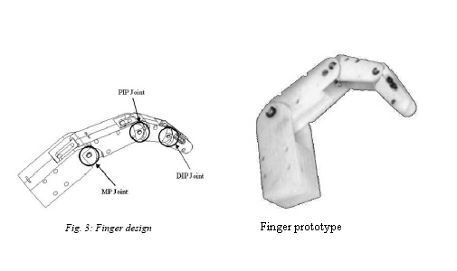

3.1 ACTUATOR SYSTEM ARCHITECTURE

In order to match the size of a human finger, two micro motors have been integrated within the palm housing and the proximal phalange of each finger.
The selected micro motors are Smoovy (RMB, eckweg, CH) micro drivers (5mm diameter) high precision linear motion using lead screw transmission.
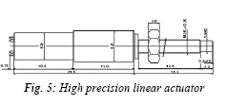
The main mechanical characteristics of the linear actuators are listed below.
TABLE 1
Summary of the main characteristics of the Smoovy (RMB, eckweg, CH) micro drivers (5mm diameter)

Nominal force | 12N
Maximum speed | 20 mm/s
Weight | 3.2 g
Maximum load (axial) | 40 N
Maximum load (radial) | 25 N
Transmission rate | 1:125
Gear stages | 3
The selected actuator fulfills almost all the specifications for application in the prosthetic finger: small size and low weight. The main problem encountered is related to noise which turns out to be relatively high, at least in the current implementation. Despite of this limitation, we decided to proceed with the application of the linear actuator in order to investigate integration problems and global performance.

The shell housing provides mechanical resistance of the shaft to both axial and radial loads system. This is very important during grasping task, when the forces generated from the thumb opposition act bon the whole finger structure.

3.2 KINEMATICS ARCHITECTURE

The kinematics of each finger joint is described in the following subsections.

1. MP joint: the proximal actuator is integrated in the palm and transmits the movement through a slider –crank mechanism to the proximal phalanx, thus, providing flexion/extension movement. The slider is driven by the lead screw transmission mounted directly on the motor shaft.
2. PIP joint: the same mechanism used for MP moves the PIP joint. Only the geometrical features in order that the size of the mechanism fits within the space available according to the strict specification of the biomechatronic hand.
3. DIP joint: a four bars link has been adopted for the DIP joint and its geometrical features have been designed in order to reproduce as closely as possible the natural DIP joint flexion. The mechanism has been synthesized according to the three prescribed position method.

Due to the high transmission rate (planetary Gears and lead screw transmission) friction is high and, thus, the joints are not back-drivable. This causes problem in controlling accurately in hand. However the positive side effect of friction is that the grasping forces can be exerted even when power supply is off, a very important function for hand prostheses.

3.3 THUMB DESIGN

The thumb has been designed to perform grasping task by thumb opposition. The thumb has been obtained by simply removing the distal phalanx from the index/middle finger.
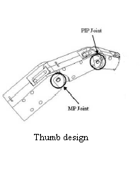

Chapter -4

HAND FABRICATIONS

The hand protected comprises the three fingers (index, middle and thumb) ,each with two-DOF’s actuated by micro motors and sensorised by hall-effect position sensors and by strain gauge-based force sensors. The characteristics of the position sensors and the force sensors are illustrated in following sections.

The three fingers have been fabricated using the Fused Deposition Modeling (FDN) process. This process allows obtaining 3-E complex shapes from CAD models easily, quickly, and cheaply. The main limitation of the FDM process resides in poor mechanical characteristics of the material that must be used, which is acrylonitrile/butadiene/(ABS) however this is acceptable for a prototype.

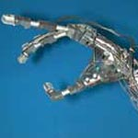

Chapter -5

POSITION AND FORCE SENSORS

5.1 SENSORS

Sensors are used as peripheral devices in robotics include both simple types such as limit switches and sophisticated type such as machine vision systems. Of course sensors are also used as integral components of the robots position feed back control system. Their function in a robotic work cell is to permit the robotic activities to be co-ordinate with other activities of the cell.

1) TACTILE SENSOR: These are sensors, which respond to contact forces with another object; some of these devices are capable of measuring the level of force involved.

2) PROXIMITY AND RANGE SENSOR: A proximity sensor that indicates when an object is close to another object but before contact has been made. When the distance between the objects can be sensed, the device is called a range sensor.

3) MISCELLANEOUS TYPES: The miscellaneous category includes the remaining kinds of sensors that are used in robotics.

4) MACHINE VISION: A machine vision system is capable of viewing the workspace and interpreting what it sees. These are used in robotics to perform inspection, part recognition and other similar tasks.

5.2 USE OF SENSORS IN ROBOTICS

The major use of sensors in robotics and other automated manufacturing systems can be divided in to four basic categories.

1) Safety monitoring.
2) Inter locks in work cell control.
3) Part inspection for quality control.
4) Determining position and related information about objects in the robot cell.

5.3 POSITION SENSORS

A position sensor, based on the Hall Effect sensor is mounted at each active joint of the hand. The main advantages of Hall Effect sensors are there small sizes and their contact less working principle. In each finger, the hall sensors are fixed, respectively, to the palm and to the proximal phalanxes, where as the magnets are mounted directly on the sliders of each joint.

In this configuration the sensor measures the linear movement of the slider, which is related to the angular position of the joint. In each MP joint, the linear range of the sensor is 5.2mm, where as in the PIP joint the linear range is 8mm.
Using a micrometric translator stage we found optimal configurations for the position sensors. In the first optimal configurations two magnets are used at a distance of 3.5 mm this configuration has a working range of 5.4mm with a linearity of 5.34%. The second optimal configuration (suitable for MP joints) has six magnets and a working range of 8.4mm with a linearity of 3.81%.
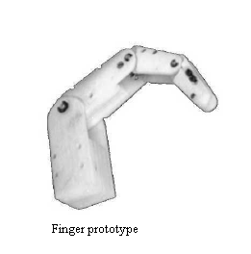

5.4 HALL EFFECT SENSORS

When a beam of charged particles passes through a magnetic field, forces act on the particles and the beam is deflected from its straight line path. A current flowing in a conductor is like a beam of moving charges and thus can be deflected by magnetic field. This effect is known as HALL EFFECT. Consider electrons moving in a conductive plate with a magnetic field placed at right angles to the plane of the plate. As a consequence of magnetic field, the moving electrons are deflected to one side of the plate and thus that side becomes negatively charged while the opposite side becomes positively charged since the electrons are directed away from it.

This charge separation produces an electric field in the material. The separation continues until the forces on the charged particles from the electric field just balance the forces produced by the magnetic field. The result is a transverse potential difference given by

V=KhBI/t

Where,

B is the magnetic flux density at right angles to the plate, I current through the plate, t the plate thickness, K the constant called Hall Co-efficient. Thus if a constant current source is used with a particular sensor, the Hall voltage is a measure of the magnetic flux density
Hall effect sensors are generally supplied as in integrated circuit with the necessary signal processing circuitry These are two basic forms of such sensor, LINEAR where the output varies in a reasonably linear manner with the magnetic flux density and THRESHOLD where the output shows a sharp drop at particular flux density.

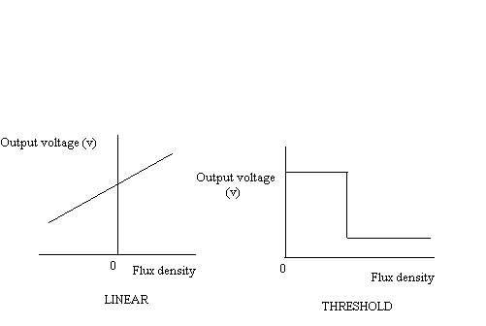

5.5 2D FORCE SENSORS

A 2-D force sensor, based on strain gauge technology, has been developed in order to sensorize the distal phalanx of the index and middle fingers. The sensor design has been optimized using the Pro/Mechanical structure software.

5.6 SENSORS CHARCTERIZATION

1. Characterization of position sensors: we found that the best simplest way to characterize these sensors is use an optical method. Used a Nikon Coolpix 950 digital camera mounted on a tripod I order to record the movement of the finger. The movement of each Smoovy actuator was driven by a CCS00001 controller (RMB, CH).each controller has a power supply of 11V, while each sensor was supplied with 6V.

For each active joint 100 different frames, 50 for flexion and 50 for extension movements where acquired. For each frame the output value of the sensor was measured with a digital multimeter and recorded, where as the position of the joint was measured using the module measures to Adobe photoshop 5.5 with a precision of 0.1°.
Result are represented in fig 9. For the sensor in MP joints and in the PIP joints, respectively. The flexion phase is indicated with a small dark circles, while the extension is indicated small light squares.

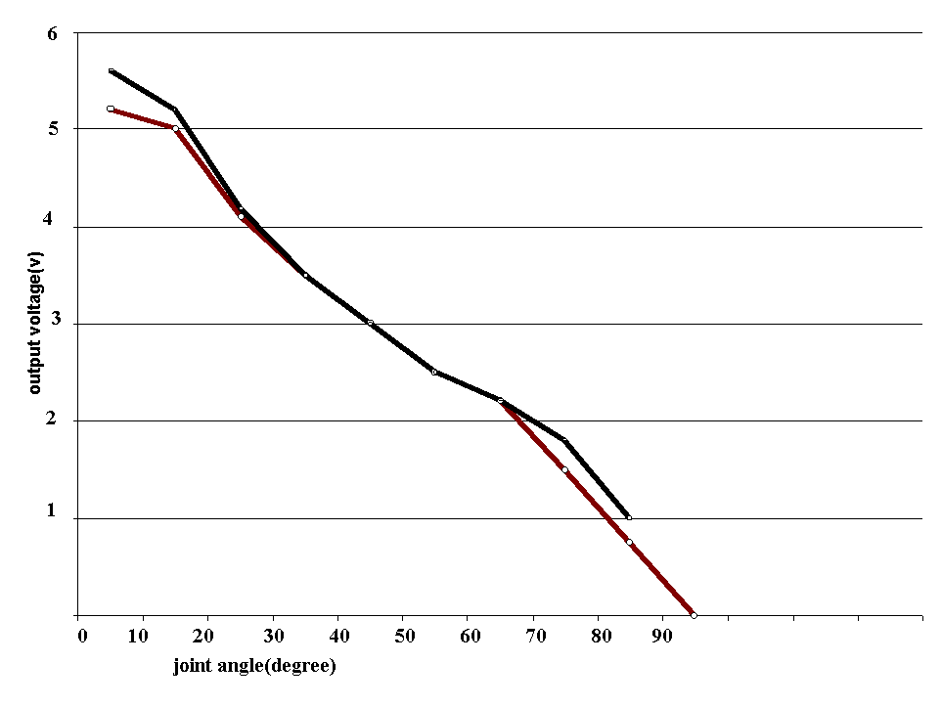

It is important to point out the both curves for both sensors generally present low hysterieses. The difference between the flexion and the extension curves is mainly due to the mechanical clearance of the sensorised slider.

2. Characterization of 2-D force sensor : the force sensor was characterized using an INSTRON 4464 testing machine.

A traction-compression loading cycle (0N-10N-0-N) was performed for each direction. Results are presented in fig 11, for the normal loading direction and the tangential loading direction respectively. Diagram show a linear behaviour of the 2-D force sensor.

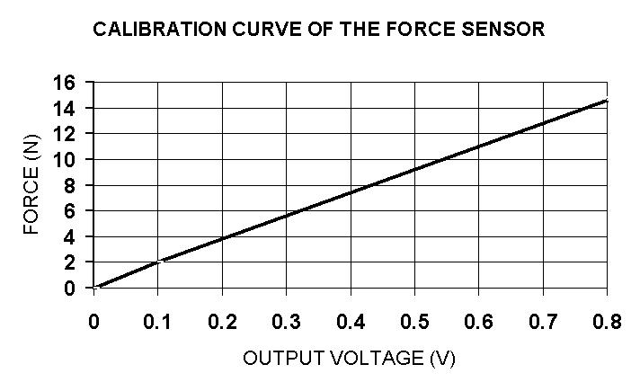

CHAPTER -6

FINGERED TRIP FORCE ANALYSIS

A first set of experimental test has been performed in order to evaluate the force that the index /middle finger is able to exert on an external object. To this aim we are measuring the force resulting when the finger is pressing directly on the high accuracy piezo electric load cell corresponding to different configurations of the joints.

To “pressing “task were identified in order to evaluate separately and independently the force generated by actuators of the fingers.

TASK 1: The pushing action is exerted only by the distal actuator.

TASK 2: The pushing action is exerted only by the proximal actuator.
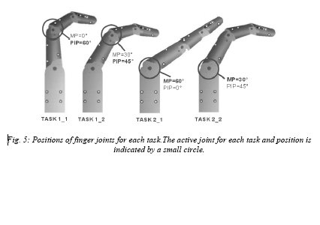
The ten tests were performed for each subtask. The results obtained are illustrated in the fig.

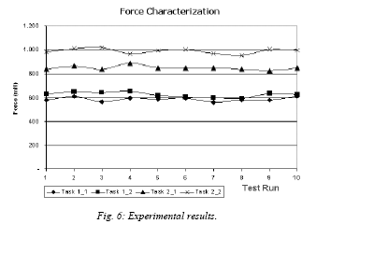

CHAPTER -7

FUTURE IMPROVEMENTS

The experimental test showed promising results, but there is still room for improvement. First of all, natural fingers movements during grasping activities will be further investigated inorder to achieve a truly “ human-like “ behaviour of the artificial finger. Force sensor measurements will be further investigated inorder to sense incipient slippage and to obtain force sensing abilities. Finally, suitable control strategies will be investigated and applied inorder to develop a natural control of the wearable hand.

CHAPTER-8

CONCLUSIONS

In this paper, novel approach to the design and fabrication of prosthetic hands, called biomechatronic design, has been presented. The biomechatronic design consists of integrating multiple DOF’S finger mechanisms, multisensing capabilities and distributed control inorder to obtain human like appearance, simple and direct controllability and low mass. The biomechatronic design approach can lead to the development of hand and prostheses, when combined with other important factors, such as low energy consumption for adequate autonomy (at least 8 hours between recharges), noiseless operation for not disrupting social interactions, cost suitable for support by the health insurance system and above all sensory feedback to the amputee through interfaces. A biomechatronic hand prototype with three fingers and a total of six DOF’s has been designed and fabricated. This paper is focused particularly on the analysis of the actuation system, which is based on miniature electromagnetic motors.

Current work is directed to improve the limitations of the prosthesis is presented in this paper.First of all, a new design has been designed aimed at increasing the grasping force of the hand while retaining the main positive characteristics of previous design .The new hand architecture is based on under actuated mechanisms, comprising a total of two dc motors. The hand has nine independent DOF’s (so it can still grasp rather effectively objects of complex shape)_ and can generate grasping force of about 30N.

A second important objective that is to implement a neural of the hand by means of interfaces implanted at peripheral nerves of the amputee. This very challenging goal could ultimately lead to the development of a truly cybernetic hand, controlled and received by the amputee almost at his/her own lost hand and, therefore, a real potential alternative to hand transplantation.

